Metroidvania

Noo181604

Supervisor: Catherine Noonan

Second Reader: Joachim Pietsch

Joshua Seymour (Student)

Year 4 2023

Dl836 BCs (hons) in Creative COmputing

# Abstract

# Acknowledgements

# 1 Introduction

# 2 Research

The Author wrote a literature review where they look at why a user’s experience is important, what makes it enjoyable and how it can be achieved through a design process.

# 2.1 Introduction

For this literature review I was focused on looking at UX in general, I am interested in how good UX is achieved. I hope to implement what I research into my final project. I want to mainly focus on what is UX and what makes it enjoyable, to do this, I will look at readings that are or could be related to video games so that I can apply what I learned to my final project. In this literature review I will be researching topics surrounding UX which consists of, What User Experience is and why it is important, how creating good characters can make the UX more enjoyable for video games and how flow theory helps with UX. Also, I will be looking into the UX design process and seeing What is UX design, The effect of good UX design and how it is implemented.

## 2.1.1 What is User Experience (UX)?

UX is a design procedure that is focused on making catered experiences with any technology, product, and service. Interactions with these experiences can be physical, mental, or mechanical. UX includes all the touch points a user has with the product, service or technology, these points include experiences such as, finding, purchasing, using, repairing / maintaining the product, service, or technology *(Rosenzweig, E., 2015)*. How a user interacts with and experiences a product is their User Experience.

## 2.1.2 Why is the User’s experience important?

The UX design process focuses on placing the user in the centre and creating everything around them, so when the product is fully created, the experience will be instinctive, accommodating and hopefully enjoyable *(Nichols & Chesnut, 2014)*. It is important to focus on the UX design before the product design as it ensures the customer’s experience is the priority and assures the product won’t have to be re-developed after. Good UX design can improve people’s day to day lives in big and small ways.

For a company, having good UX is important because the users are the ones purchasing and using the product. A product with a good UX influences the user to have a positive view of the overall product, which generates customer loyalty and brings back a customer for other products created by the company. A bad experience with a product influences the user’s attitude towards the product as it is likely that the product has wasted the users time, effort, or money. When a customer has a bad experience with a product, they are much less likely to come back and try this product or related company products again. The reason for this is that our brain stores bad experiences and learns to avoid them. Bad experiences are more prominent in our mind then good experiences *(Sparks & Baumeister, 2008)*. For example, if two people are married for twenty years and they have loved each other throughout the whole relationship, one person cheating on their partner overwrites those twenty years of loving marriage *(Baumeister et al., 2001).* The disappointment of bad UX will cause unsatisfaction and overwrite the good experience causing the user to avoid the company’s product. Therefore, it is important for the company to focus on designing a good UX and continue to improve it.

# 2.2 Good video game characters

In video games well designed characters contributed to satisfying UX. In video games wanting to like or relate to the main characters is important as it is the character the users see themselves as or is rooting for. It is beneficial for the user to care for the main character instead of dislike them and not want to play as them, because of this, usually the main characters in video games tend to be attractive. In studies it has been found that attractive people are associated with being warmer, kinder, stronger, more sensitive, more outgoing, more socially persuasive, dominant, and smarter than others. Other studies have found that having ‘Babyface’ features such as large eyes and pupils, small chin, high eyebrows and forehead, small nose, full lips and cheeks resemble a baby and through evolution it’s been found that people tend to care more towards people with these features. ‘Babyface’ features are used a lot in video games when there is a character that needs to be taken care of and liked. For example, in games like “Hollow Knight” where the main character commits violent acts users are not inclined be concerned about these acts and generally brush them off because the character design makes the character forgivable (Isbister, K., 2006). Desirable character design is essential for video games as users are more inclined to connect with the characters and continue playing them, this leads to an enjoyable UX.

Stereotypes are also often used in video games. Stereotypical character designs allow users to quickly make an impression on whether the character is good or bad. Users don’t have to figure out whether an approaching character is trustworthy or possibly dangerous if their character design is based on stereotypes. i.e., an enemy’s threatening pose and menacing look will let the user know that they are dangerous. Quick first impressions are important in fast-paced games as the user needs to take in a lot of information quickly and make actions in case of possible danger (Isbister, K., 2006). Easy to read characters ensure that players are able to navigate their way easily through the game making their UX enjoyable.

# 2.3 Flow theory

A satisfying UX consists of a user that learns a product and uses it aimlessly. It has been observed that people who get immersed into activities neglect basic human needs such as food, water, and rest. In interviews of people who pursue activities for enjoyment, it has been found that the factors for entering flow are challenges or opportunities that do not exceed the persons current skills and distinct goals and instant progress feedback. Characteristics of entering the flow state include.

* High focus on present activity.
* Actively aware of current task.
* Unaware of surroundings.
* Able to predict future occurrences.
* Disregard of time.
* Activity is personally rewarding; the process is more rewarding than the end goal.

Flow state can occur in simple activities as all individual people will have unique challenges that they want to overcome. People’s personal interests are subjective therefore everyone’s experience of enjoyment is different. Distractions, unrealistic goals, or lack of skill can disrupt the flow state. Peoples personal interest increases growth in skills as they pursue activities that are just above their skill level. The constant progress and achievement of goals results in them repeating that activity constantly looking for new challenges within that activity, this raises their enjoyment for the activity *(Nakamura, & Csikszentmihalyi, 2009).* This amount of immersion improves the UX of the product.

# 2.4 UX Design Process

## 2.4.1 What is UX design

Design is a thought-out plan that focuses on creating a final piece of art that is user centric. Good designs are often un-noticed as we expect products to do what they are advertised to do; however, excellent, or bad designs are noticed because they are either highly appreciated or frustrating. A planned design consists of

* Point
* Line
* Form, Shape, Space
* Movement, Direction
* Colour, Value
* Pattern
* Texture
* Size

The shape and form of a product is based on the function of the product and its intended use. The form must complement the products purpose. Good product form will ensure the intended use of the product, making it intuitive to the user. Bad form will make the product less ergonomic and annoying to use. Design is a way to solve problems with an end goal in mind, it’s based on concentrating on recurring problems and making life easier. Good design concentrates on solving problems that haven’t been solved before in hopes of achieving innovation and overwriting previous technology *(Rosenzweig, E., 2015).*

## 2.4.2 The Effect of good UX design

People learn in a multitude of ways as not every person is the same, some people take in information in visual, auditory, reading and writing and kinesthetic learning styles. Every individual will interact with products in unique ways. People interact with products in ways that accommodate their needs, for example, people with physical disabilities such as visual impairment will require tools that help with vision. UX design must be aimed towards one main target audience, however, should consider people outside the main group and make their product more widely accessible.

To keep good UX design in mind a Persona can be used to guide the design in the right direction. A persona may be developed when considering a problem in mind. The design of a specified persona will help guide the product design towards the target market. When designing a persona, the characteristics that are often included are

* Demographics: Age, Gender, Education level.
* Goals
* Limitations
* Motivations
* Environment

This ensures that the product is tailored towards the intended audience answering questions like: What are they trying to achieve, what obstacles do they face, what motivates them and what conditions surround them *(Rosenzweig, E., 2015).*

## 2.4.3 How UX design is implemented

Once the relevant research and planning has been done and a persona has been established, the product itself can be designed and fabricated. The order of UX design process should be done in 5 stages, which are:

* Concept, sketching and flows
* Wireframes and prototyping
* Visual design and interactions
* Documentation
* Development

Concepts – With all relevant data obtained, the start of a concept can begin. Methods such as, storyboards, project briefs or project outlines help with coming up with product concepts, it can help visualise what the product will be used for or how it will be used.

Sketching – Sketching is the most efficient way to quickly visualise many variants of concepts for the final product. It allows the developer to visualise many possibilities, pick the best suited option and develop it. Seeing the sketch helps pinpoint where there might be design flaws. These flaws can then be singled out and solved before the final concept is decided on. All the final details of the finished product don’t have to be included in the sketches as sketching is an early stage of concept designing and it is there for a basic visualisation of the product.

Flow – Flow is the state of moving from one stage to the next stage of a product. Every interaction will lead to another interaction in a product until the user’s desired outcome has been reached. For example, every interaction on a phone brings a user to a new screen or popup that leads them further to their desired screen location.

Wireframe – Wireframes are a sketched out visual guide that show the products structure and shows the main features and elements of the product. When the wireframes are made, the flow of the product are also incorporated into the wireframe sketches. Wireframes are created first by sketching them in a low-fidelity version which will have basic necessary features. Wireframes are created to show the structure and how the most essential interactions with the product will look like. A good wireframe will become an important reference for the prototype stage.

Prototyping – Prototypes are used as a representation of what the final concept may look like, it allows its developers and users to view the potential final product and consider its feasibility. Prototypes should include all of the key elements from the concept design, this means that they are generally high-fidelity as they are made to be more interactive and more suited for the end user.

Visual Design & Interactions – Visual Design is how the final product appears to the user and how it responds when interacted with. Visual Design is created by combining UI design and graphic design. Visual Design includes important elements such as: colours, text, images, and form, these help with understanding the product visually. A consistent and understandable style needs to be created and implemented throughout the product. The UI designer is responsible for creating high quality designs that are universally readable and a layout that is easy to navigate. The interface should be clear and smooth so the user can easily tell that an interaction has taken place, for example, when a user clicks on a desktop icon, a loading symbol appears beside the pointer to let the user know that the computer is processing.

Documentation – Documentation occurs after the design has been planned and decided on. Documentation is the process of recording all final decisions that have been made for the design of the product and organising it into different divided sections. A well organised documentation will help future developers to understand what is being requested to develop.

Development & Production – lastly the design gets sent to a development team where development begins. During the development phase the developer may send back the product for review or give feedback and receive clarification. Changes may be made during the development stage as feedback gets sent back and forth. All changes made get recorded into the documentation. The product is developed until a satisfying outcome is reached. The developed product gets quality checked and goes through usability testing. The performance of the product is measured and corrected. The product is eventually launched, and feedback is taken into consideration *(Canziba, E., 2018).*

# 2.5 Conclusion

In conclusion I have found that UX is a design process that is catered for specific users. Good UX design is important as it ensures that the user is the priority of the product design, and they are satisfied with the product. This guarantees that a company has not wasted time, effort, or money in making products that are unsatisfying. For video games, good character design is more likely to make a user invested in the game and become immersed increasing their UX satisfaction. UX design is a plan that focuses on creating a product for a user, good UX design takes into consideration how the product can be more suited towards a specified target audience. There are many steps taken for a UX design to be implemented, these steps make sure that the final product is catered towards the targeted audience and will be successful.

# 2.6 References

Baumeister, R., Bratslavsky, E., Finkenauer, C., & Vohs, K. (2001). *Bad is Stronger than Good - Roy F. Baumeister, Ellen Bratslavsky, Catrin Finkenauer, Kathleen D. Vohs, 2001*. SAGE Journals. Retrieved 21 December 2021, from <https://journals.sagepub.com/doi/abs/10.1037/1089-2680.5.4.323>.

Canziba, E. (2018). *Hands-On UX Design for Developers*. Ebookcentral.proquest.com. Retrieved 21 December 2021, from <https://ebookcentral.proquest.com/lib/iadt-ebooks/reader.action?docID=5485019&query=>.

Isbister, K. (2006). *Better Game Characters by Design A Psychological Approach*. Gamifique.files.wordpress.com. Retrieved 23 December 2021, from <https://gamifique.files.wordpress.com/2011/11/9-better-game-characters-by-design-a-psychilogical-approach.pdf>.

Nakamura, J., & Csikszentmihalyi, M. (2009). *Oxford Handbook of Positive Psychology*. Google Books. Retrieved 22 December 2021, from <https://books.google.ie/books?hl=en&lr=&id=6IyqCNBD6oIC&oi=fnd&pg=PA195&dq=flow+theory+csikszentmihalyi&ots=INFcVKY8pz&sig=1S-Gkx8oYfsF3VSVGvcHBlMdvFw&redir_esc=y#v=onepage&q=flow%20theory%20csikszentmihalyi&f=false>.

Nichols, K., & Chesnut, D. (2014). *UX for Dummies*. Ebookcentral.proquest.com. Retrieved 21 December 2021, from <https://ebookcentral.proquest.com/lib/iadt-ebooks/reader.action?docID=1674223&query=>.

Rosenzweig, E. (2015). Successful user experience : Strategies and roadmaps. Elsevier Science & Technology. Retrieved 21 December 2021, from <https://ebookcentral.proquest.com/lib/iadt-ebooks/reader.action?docID=2122438>.

Sparks, E., & Baumeister, R. (2008). *Positive Psychology: Exploring the Best in People*. Images-insite.sgp1.digitaloceanspaces.com. Retrieved 21 December 2021, from <https://images-insite.sgp1.digitaloceanspaces.com/dunia_buku/koleksi-buku-neuro-science/positive-psychology-exploring-the-best-in-people-4-volumes-set-pdfdrivecom-66441577416922.pdf#page=68>.

# 3 Requirements

This chapter will focus on the requirements to make a game. This chapter will investigate similar games, a survey which gathers information on what people want from a 2D game, personas, functional requirements, non-functional requirements, a wireframe sketch of the game map, a story board of the game, what software the Author will use, and the difficulties the creator of the game will potentially encounter. The author’s game will be 2D and contain an interesting environment along with a boss (hopefully multiple bosses) the player can fight. The game will have abilities that the player can find upgrades for, and it will have multiple different types of enemies and allies for the player to interact with and fight.

## 3.1 Similar games

**Hollow Knight**

**Figure 1** is a screenshot of a game called *Hollow Knight (CHAN, 2022).* The creator wants to make a game similar to Hollow Knight, however the scope will be smaller as there is not a team of developers working together.In **figure 1** there is 5 skulls representing the players health bar. Under the skulls there is a number representing the money the player has, and to the left there is a big circle that will fill up with “soul” when the player damages enemies. The player can use this “soul” to heal.

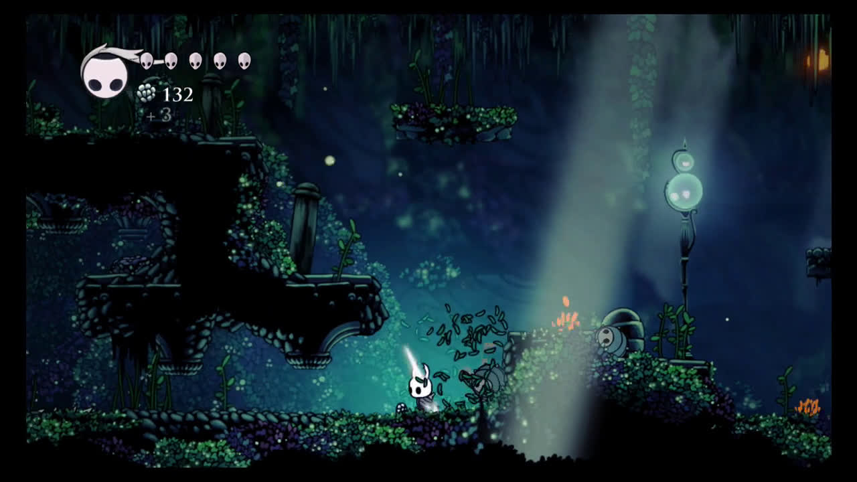

Figure 1: Screenshot of Hollow Knight game environment and UI

**Figure 2** displays the different types of enemies. The player can encounter in Hollow Knight *(Locke, 2022)*.

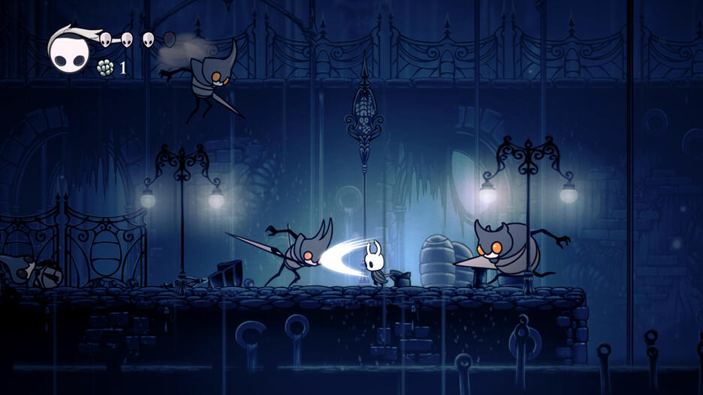

Figure 2: Screenshot of Hollow Knight game showing different types of enemies.

**Figure 3** shows one of the many boss fights from Hollow Knight. Most of the boss fights in Hollow Knight have two phases. The first phase being easier and the second adding another ability or more challenge to the fight.

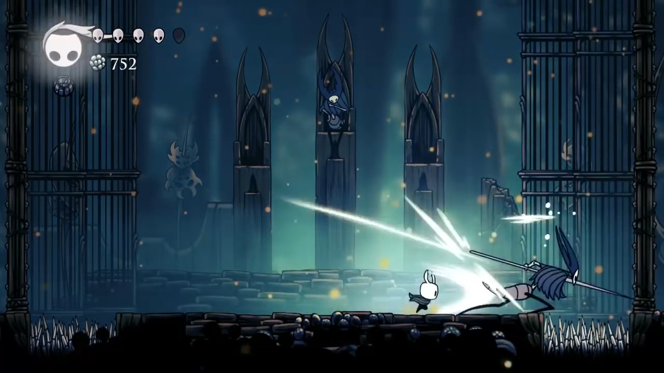

Figure 3: Screenshot of a Boss fight in Hollow Knight

**Ori and the Will of the Wisps**

**Figure 4** and **Figure 5** are screenshots of a similar game called *Ori and the Will of the Wisps (Irwin, 2022).* The game is a 2D Metroidvania. Metroidvania is a sub-genre of action-adventure games where the player can explore a nonlinear story line while also having progression based on upgraded abilities.In this game the player encounters many incredible characters and is compelled to explore the beautiful world while following along with the story of the game.

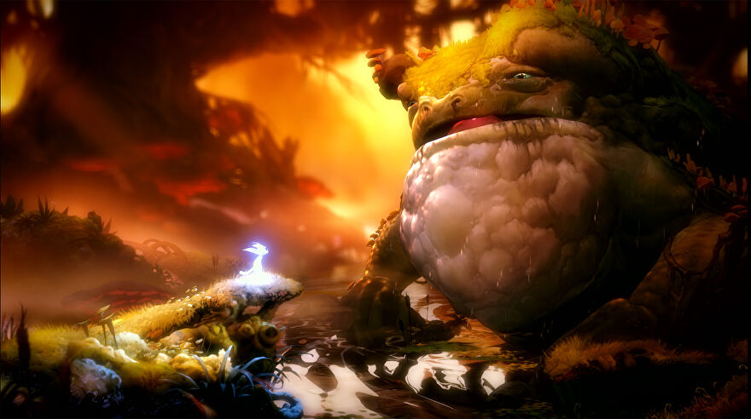

Figure 4: Screenshot from Ori and the Will of the Wisps showing the player interacting with the creatures in the world.

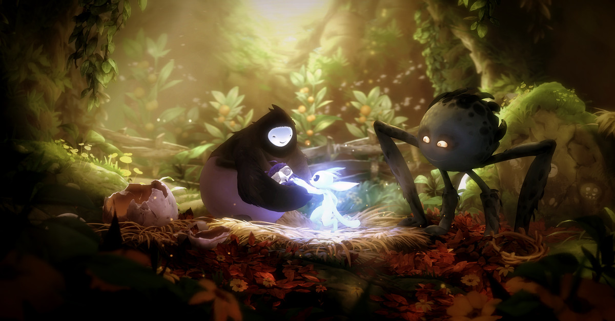

Figure 5: Screenshot from Ori and the Will of the Wisps showing the player interacting with the creatures in the world

**Figure 6** shows a screenshot of the basic UI. In the top right there is the currency called spirit light, the player can buy maps and items with it. At the bottom middle of the screenshot there are the 3 abilities the player can use. (Ori and the Will of the Wisps PC & Console 2020, 2022)

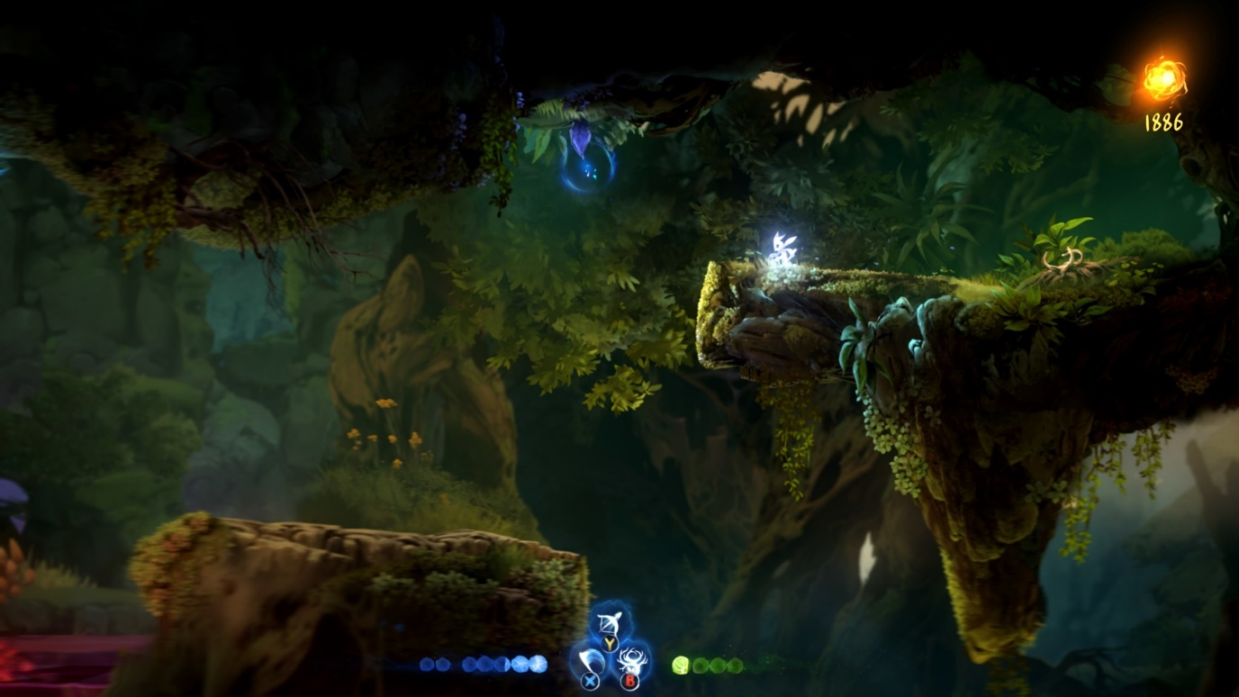

Figure 6: Screenshot of Ori and the Will of the Wisps UI

**Figure 7** shows a screenshot of the upgrade system. The player can acquire may upgrades that help the progression of the game and make it easier for the player. (Crego, 2020)

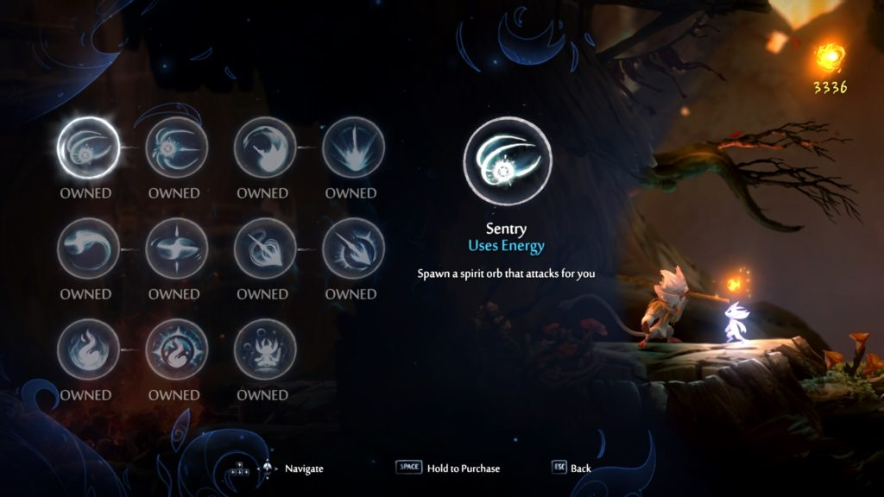

Figure 7: Screenshot of Ori and the Will of the Wisps Upgrade abilities

### 3.1.1 Advantages and disadvantages of both games

#### Hollow Knight advantages

* Art

Music / Environment / Enemies / Unique Characters

* Story

Deep lore (items and characters have a lot of backstory)

Multiple side Quests / Stories

* Exploration heavy
* Collectables

#### Hollow Knight Disadvantages

* Very difficult combat (frustrating for beginners)
* Story can be hidden and hard to follow.
* Lots of retracing your steps

#### Ori and the Will of the Wisps advantages

* Art

Music / Beautiful Characters / Beautiful World

* Story

Emotional / Captivating

* Intricate Problem-Solving Puzzles
* Exploration heavy
* Collectables

#### Ori and the Will of the Wisps disadvantages

* Very Difficult Beginning
* Poor Performance (FPS drops and stutters)
* Enemies can move and shoot at the player while the player is still loading into an area.
* No Mini Map + Unintuitive Menu Map
* Lots of retracing your steps
* End Game is too easy.

### 3.1.2 Desired Aspects

The author would like the game to be visually appealing, while having unique enemies and characters. The author wants there to be optional quests (E.g., Save certain characters and they will reward the player). The author also wants the mini map to be easy to use.

## 3.2 Survey

<https://docs.google.com/forms/d/e/1FAIpQLSeGQyMOOgO1SkYDsg4qMcWu6zxPIq0sB7CGoT2GqFFmpB1UbA/viewform?usp=sf_link>

This is the link to the Authors survey in which they ask the participant what aspects of 2D games they like and how Important they are to a game. The survey asks for the participants age and gender to see the demographic of people that took the survey.

## 3.3 Persona

**Figure 8** and **figure 9** show two personas that were created to illustrate potential users of the game. In **Figure 8** Gerry likes difficult, fun, and satisfying games while not being too interested in the story or the uniqueness. This type of player is really interested in a challenging game. In **Figure 9** Samantha is much more interested in the Story and the enjoyment of the game while not liking difficult games.

A way to solve the problem of having a game that is hard but also is accessible for people who don’t like difficult boss fights is to make the very hard fights optional.

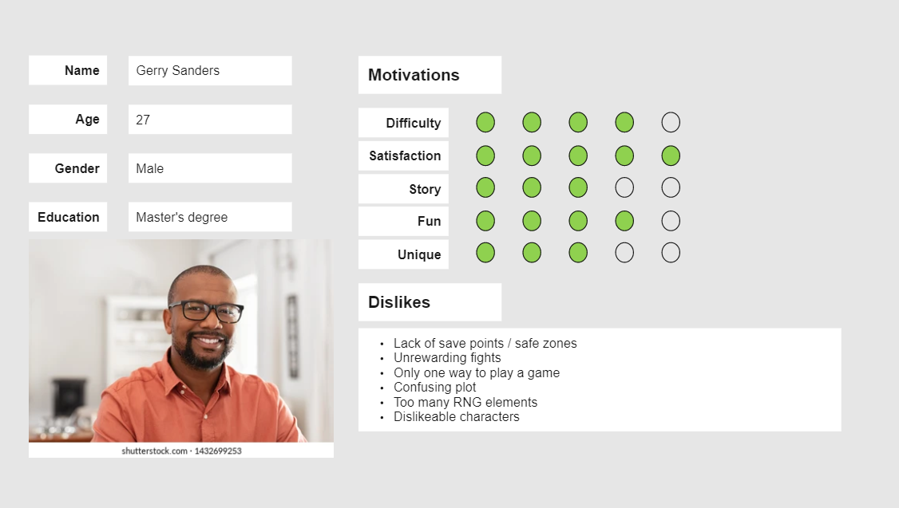

Figure 8: Persona 1

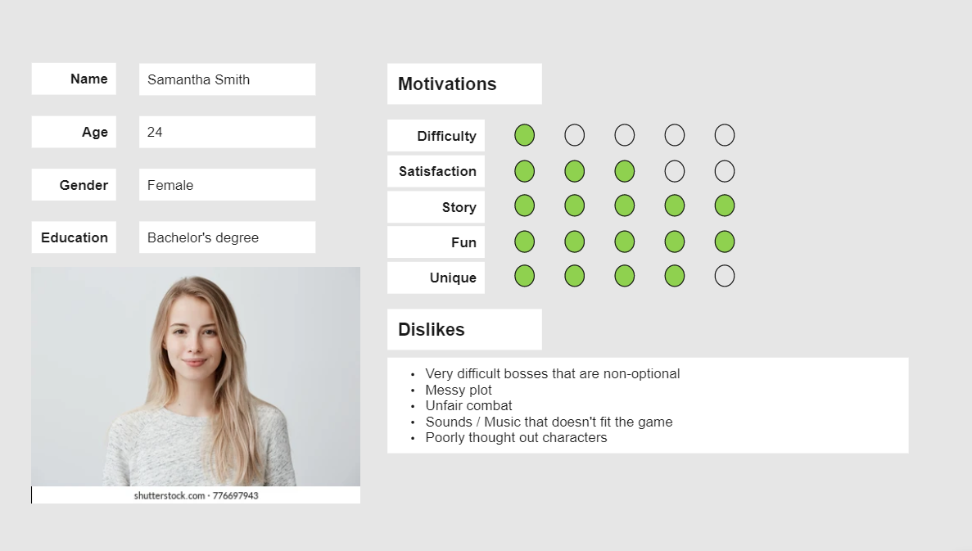

Figure 9: Persona 2

## 3.4 Functional Requirements

* Basic movement controls
* Health bar
* Sword attack
* Story progression
* Item pickups
* Enemies
* 3 different areas to explore (possibly 4)
* A boss fight for each area (this might be too much for the time frame)
* Autosave
* Save files.

## 3.5 Non-Functional Requirements

* Satisfying movement
* Pleasing Haptics
* Interactable environment + Destructible terrain

## 3.6 Software

The author researched Unreal Engine and Unity to compare which was the better option to use in their project. The author will be using Unity to create and run the game and visual studio code as their code editor. They will be using a physics engine.

### Advantages of Unity

* The Author has completed 2 projects in Unity already.
* Unity Assets store has many easily accessible free assets (mainly 2D).
* Free Software
* Compatible Cross Platform Development
* C# Coding language (easier than C++, The Author has used C# before)

### Disadvantages of Unity

* Performance-intensive
* Large Unity games take up a lot of space.
* Unity Assets store for 3D models

### Advantages of Unreal Engine

* Real-time networking for multiplayer
* Beautiful Visual Effects
* Extensive 3D Asset libraries

### Disadvantages of Unreal Engine

* C++ Coding Language (The author would have to learn this language)
* Harder than Unity to port to another platform

## 3.7 Paper Prototype

These are the Paper Prototypes the creator sketched for the map of the game.

**Figure 10** shows the starting area of the game. The player learns the controls of the game here, they learn to jump and attack.

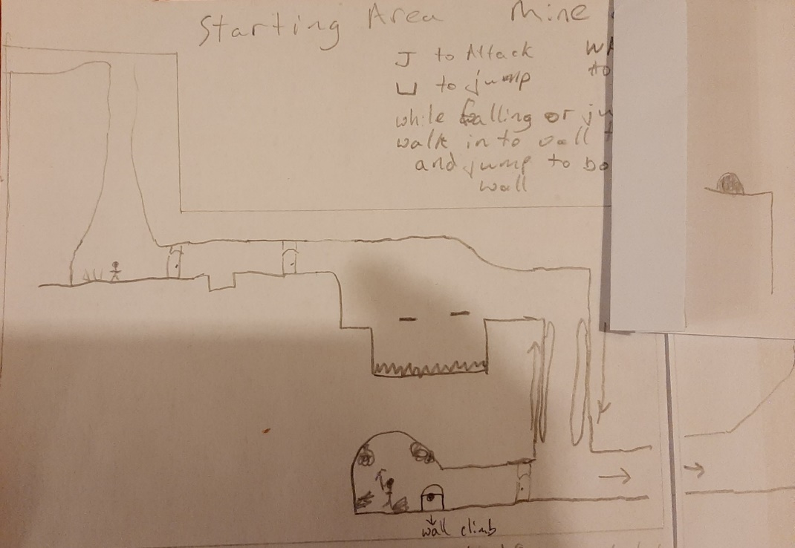

Figure 10 Starting area Paper Prototype

**Figure 11** shows the mid-section of the first area where the player learns to wall jump and scale walls. Wall jumping is when the player can jump off the wall in the opposite direction to get to different areas of the map. Wall scaling is when the player slides down a wall by walking into the wall while falling, this slows the players fall speed and allows for more time to think about where they would like to go.

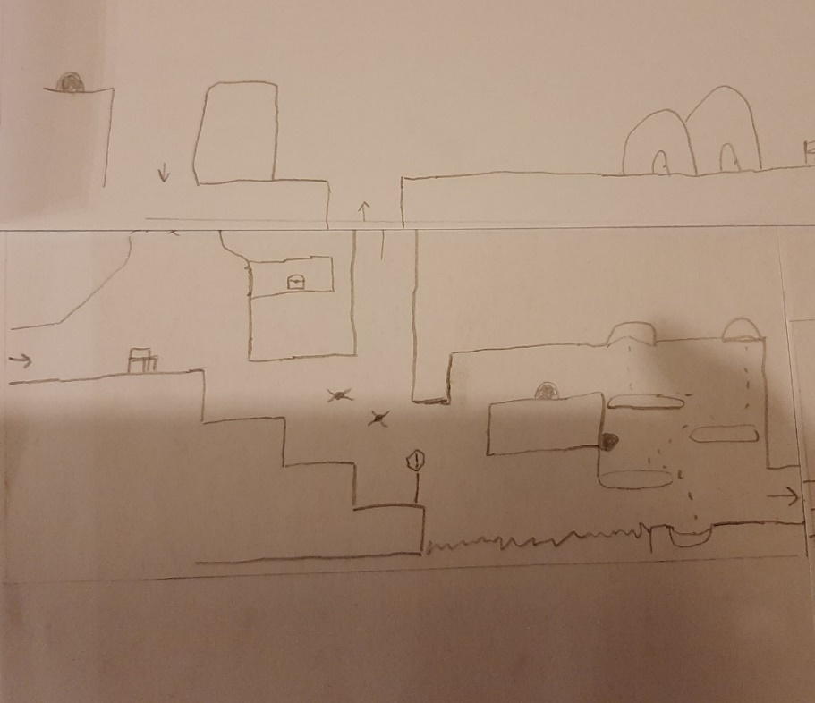

Figure 11 Starting area Paper Prototype mid-section.

**Figure 12** shows the final section of the first area, the boss fight room.

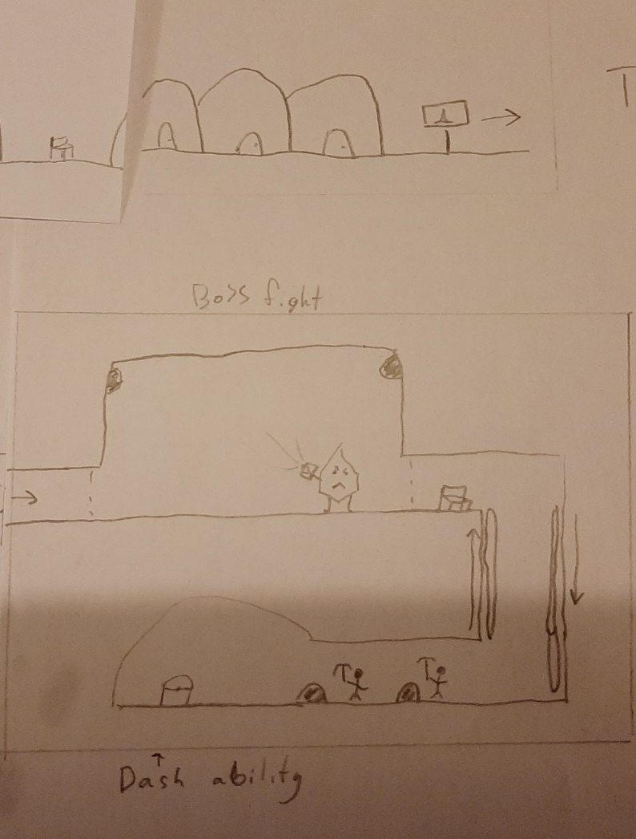

Figure 12 Paper Prototype of Boss fight of area 1

## 3.8 Story board Paper Prototype

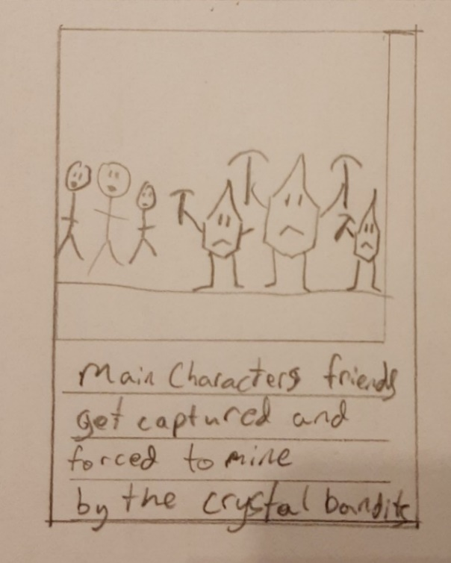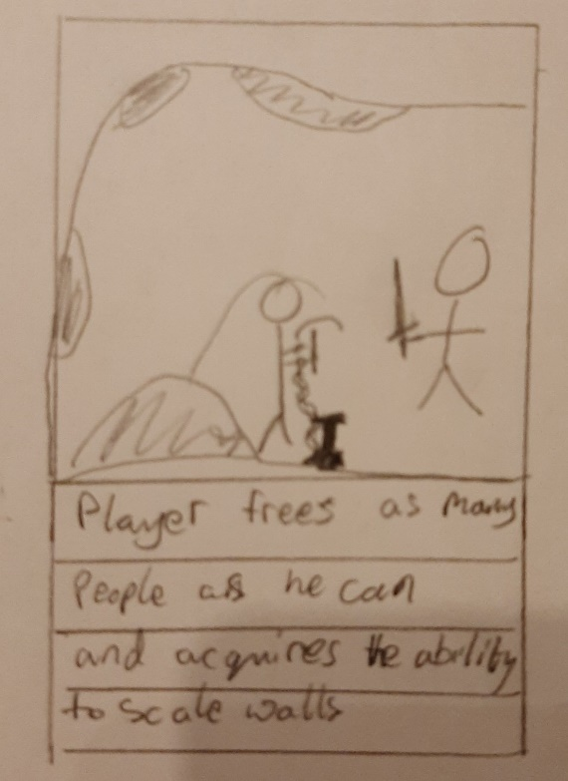

Figure 13 Story board 1 Figure 14 Story board 2

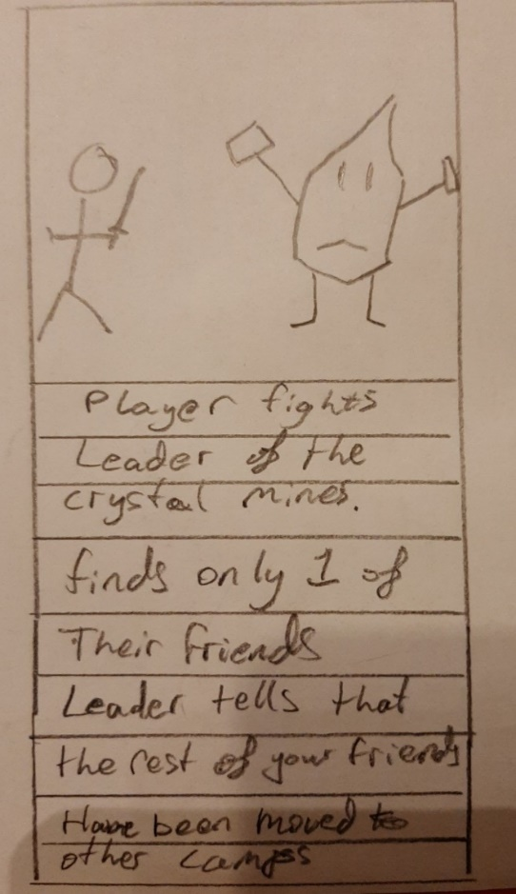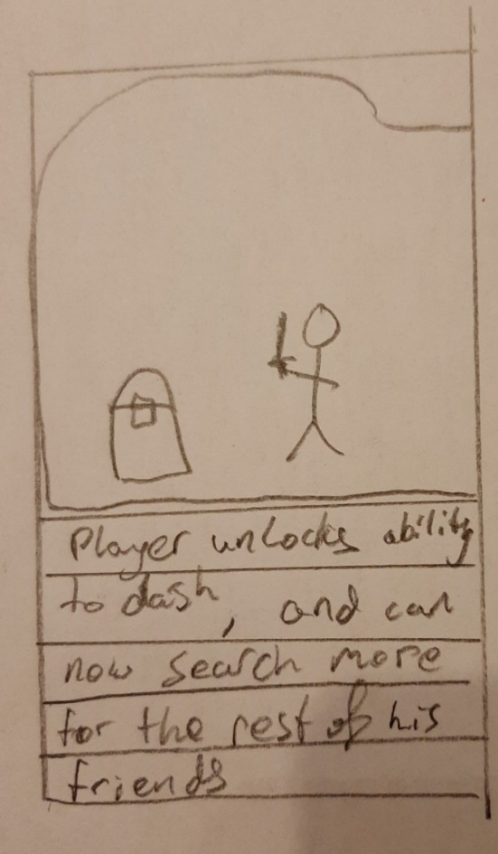

Figure 15 Story Board 3 Figure 16 Story Board 4

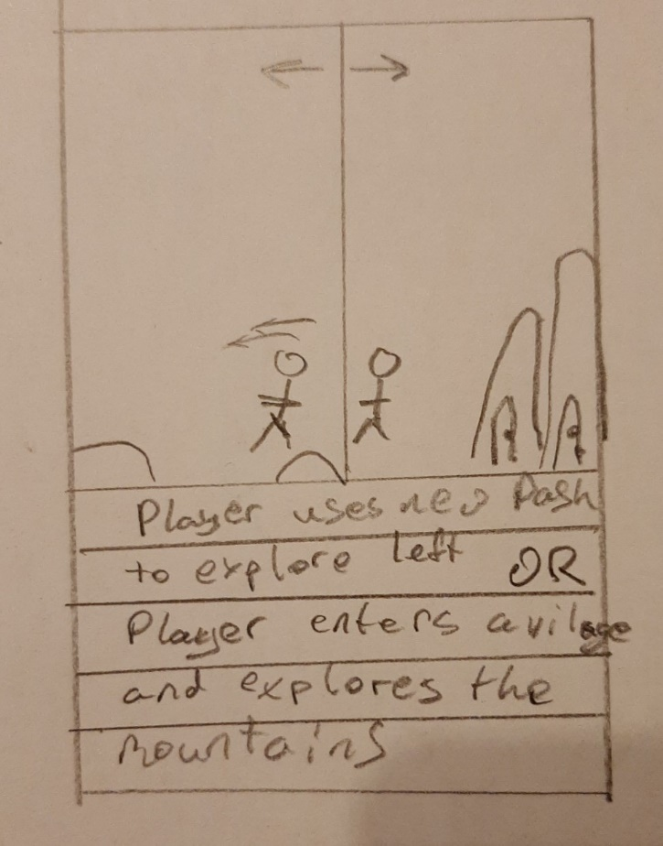

Figure 17 Story Board 5

## 3.8 Potential Difficulties

This is the author’s first proper 2D game they have only done very basic 2D games without any storyline or characters and item pickups. Therefore, the author could experience difficulties with coding enemies, coding how the camera follows the player and the bounds of where the camera can go, save files and autosave features.

## 3.9 Conclusion

The author will create a 2D Metroidvania game with basic movement controls, health bars, sword attacks, story progression, item pickups, enemies, 3 different areas to explore (possibly 4), a boss fight for each area (this might be too much for the time frame), autosave features and save files.

## 3.10 References

CHAN, C. (2022). Get lost in the best Metroidvania games for the Switch. Retrieved 11 June 2022, from https://www.imore.com/best-metroidvania-games-nintendo-switch

Crego, V. (2020). What abilities and skills to get first | Ori and the Will of the Wisps Guide. Retrieved 10 June 2022, from https://squadstate.com/guide/what-abilities-and-skills-to-get-first-ori-and-the-will-of-the-wisps-guide

Ori and the Will of the Wisps PC & Console 2020. (2022). Retrieved 10 June 2022, from https://www.gameuidatabase.com/uploads/Ori-and-the-Will-of-the-Wisps06302020-082722-71864.jpg

Irwin, D. (2022). Ori And The Will Of The Wisps guide: 20 tips for beginners. Retrieved 11 June 2022, from https://www.rockpapershotgun.com/ori-and-the-will-of-the-wisps-guide-20-tips-for-beginners

Locke, J. (2022). Retrieved 10 June 2022, from https://mspoweruser.com/hollow-knight-is-coming-to-xbox-one-with-a-physical-edition-next-year/

# 4 Design Chapter

This chapter will focus on what is important to consider in the design process. The system architecture and the UI (User Interface). This project was developed using the Unity Engine, Visual Studio Code and Photoshop. In the System Architecture section, the user’s interaction with the application is described. In the User Interface Design section, the UI sketches and high-fidelity versions of the sketches are shown. There is inspiration from similar games. In the Proposed Map Layout section, the map sketches and high-fidelity versions are shown.

## 4.1 System Architecture

### User Flow

When designing a game, the developer must think about how the user will move through the application. The developer must understand what the user will find irritating but also what the user will like and appreciate.

**Figure 1** shows how the user will interact with the main menu. The user has 3 options to pick from:

* The player can select the “Play Game” button, this starts the game at the first level.
* The player can select the “Settings” button, this opens the settings menu where the user can choose to change the audio or video settings.
* The player can select the “Quit” button, this closes the application.

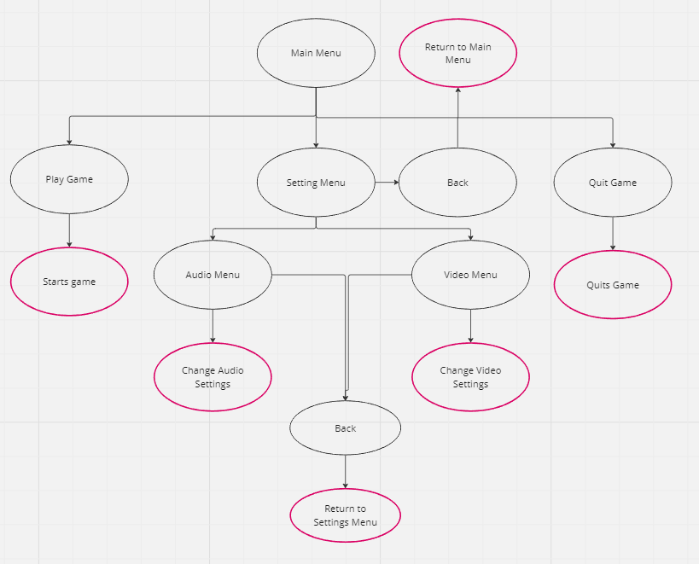

Figure 1 Main Menu User Flow Diagram

**Figure 2** shows how the user will interact with the pause menu. When the player presses the “Pause” button the game is paused. The player is then shown the pause menu. The player has 3 options to choose from:

* The “Resume” button, this resumes the game and hides the pause menu.
* The “Settings” button, this displays the settings menu where the user can change the audio or video settings.
* The “Quit” button, this returns the player to the main menu.

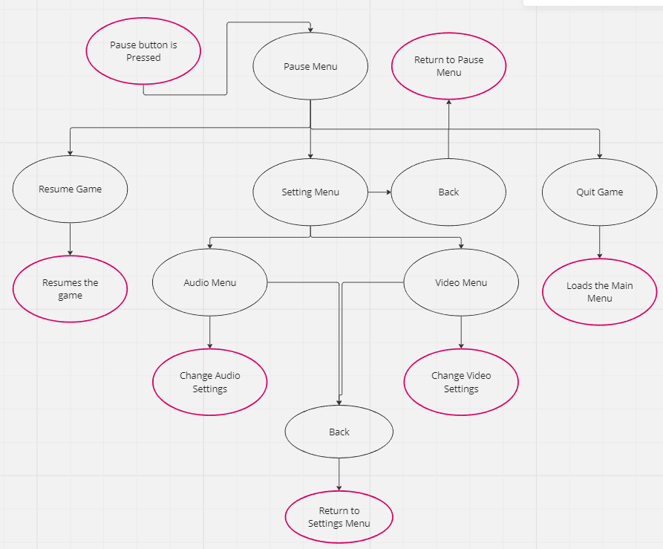

Figure 2 Pause Menu User Flow Diagram

**Figure 3** shows how the user will interact with the death menu. This is shown when the player dies. The player has two options:

The “Quit” button, this returns the user to the main menu.

The “Restart” button, this will restart the current scene.

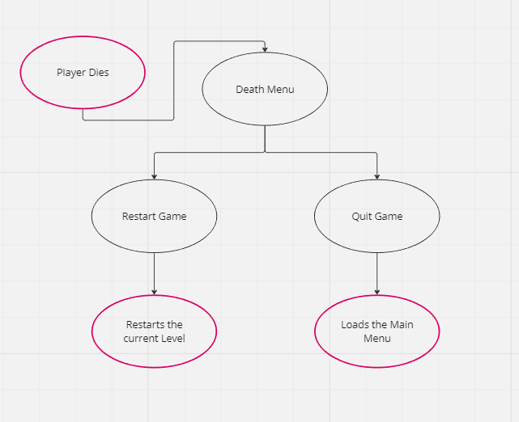

Figure 3 Death Menu User Flow Diagram

## 4.2 User Interface Design

**Figures 4 – 9** show the author’s sketches for what they want the menus to look like.

Figure 4 Start Menu sketch

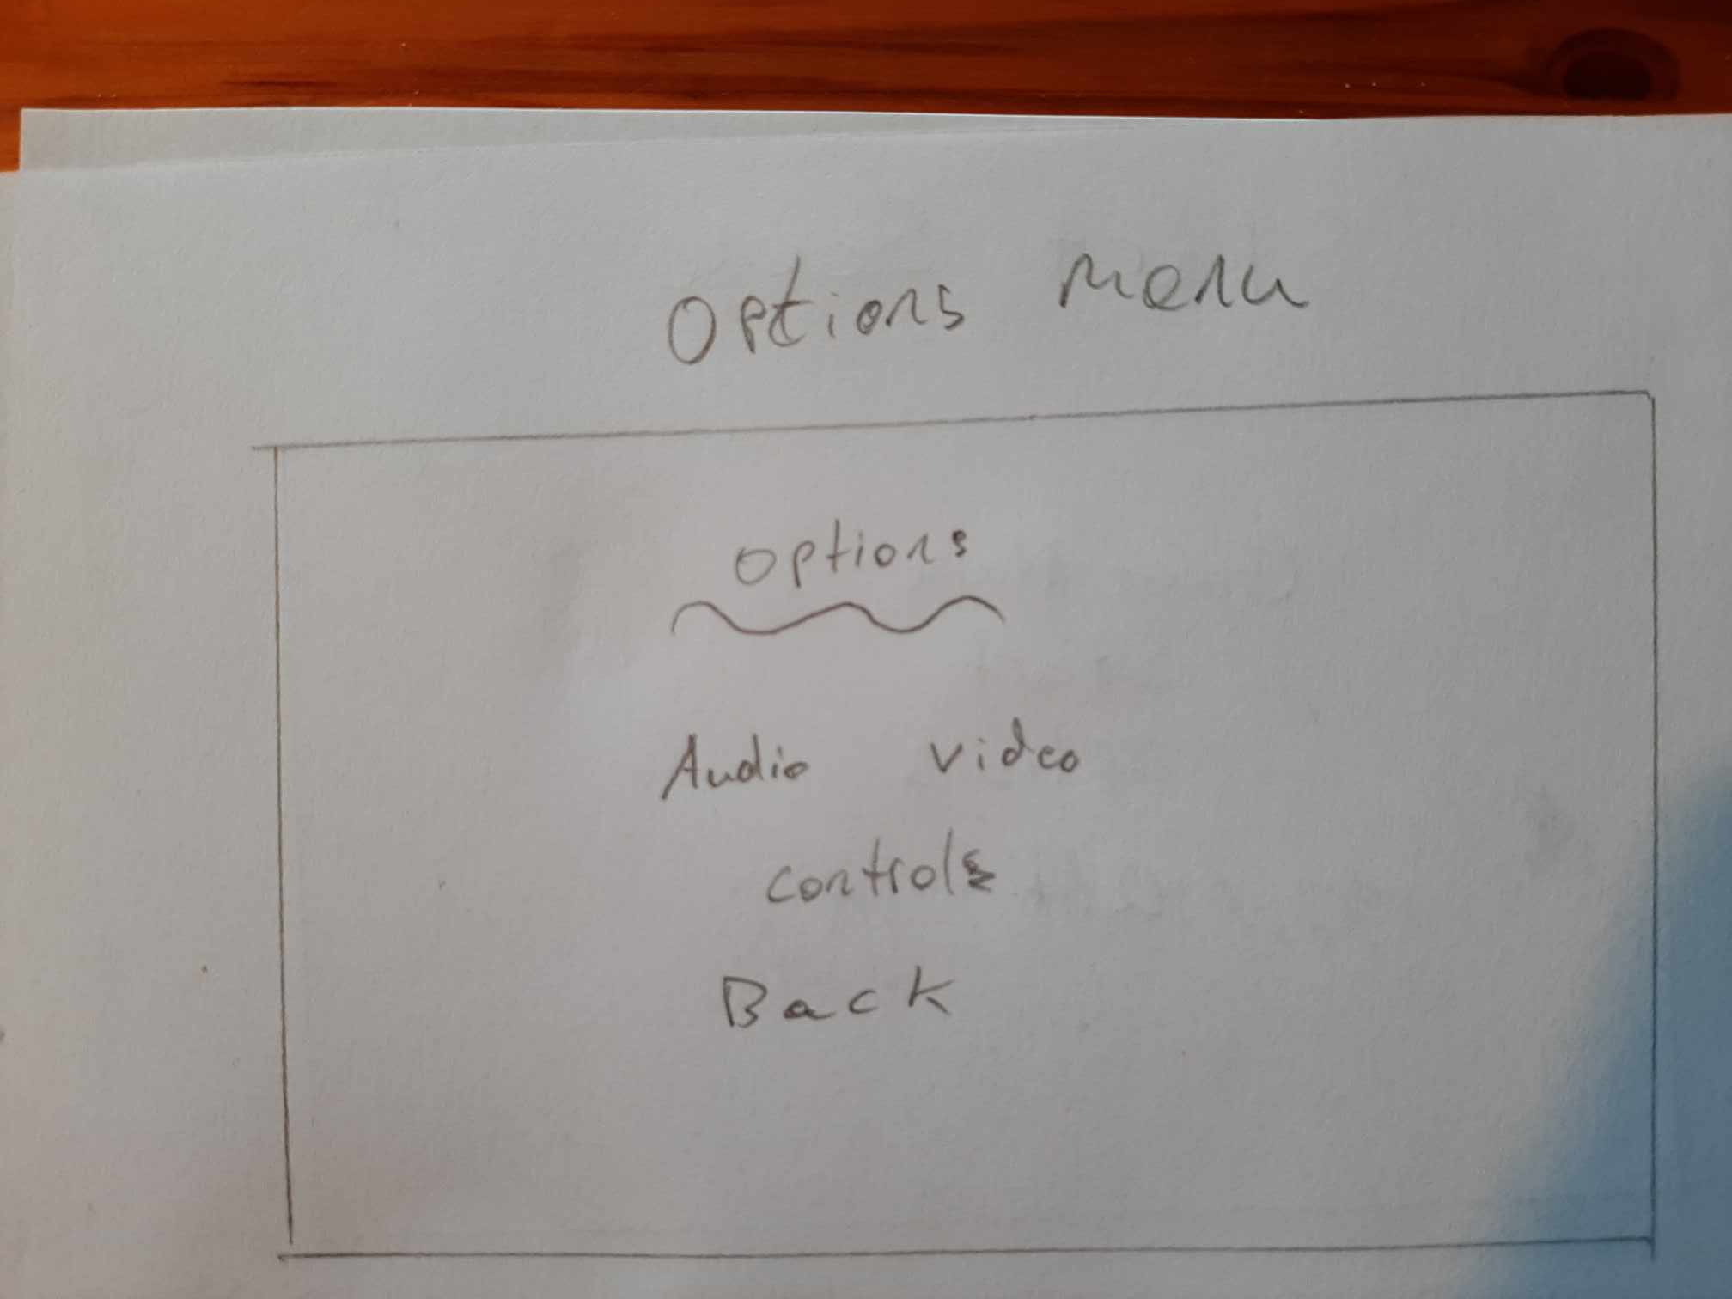

Figure 5 Options Menu sketch

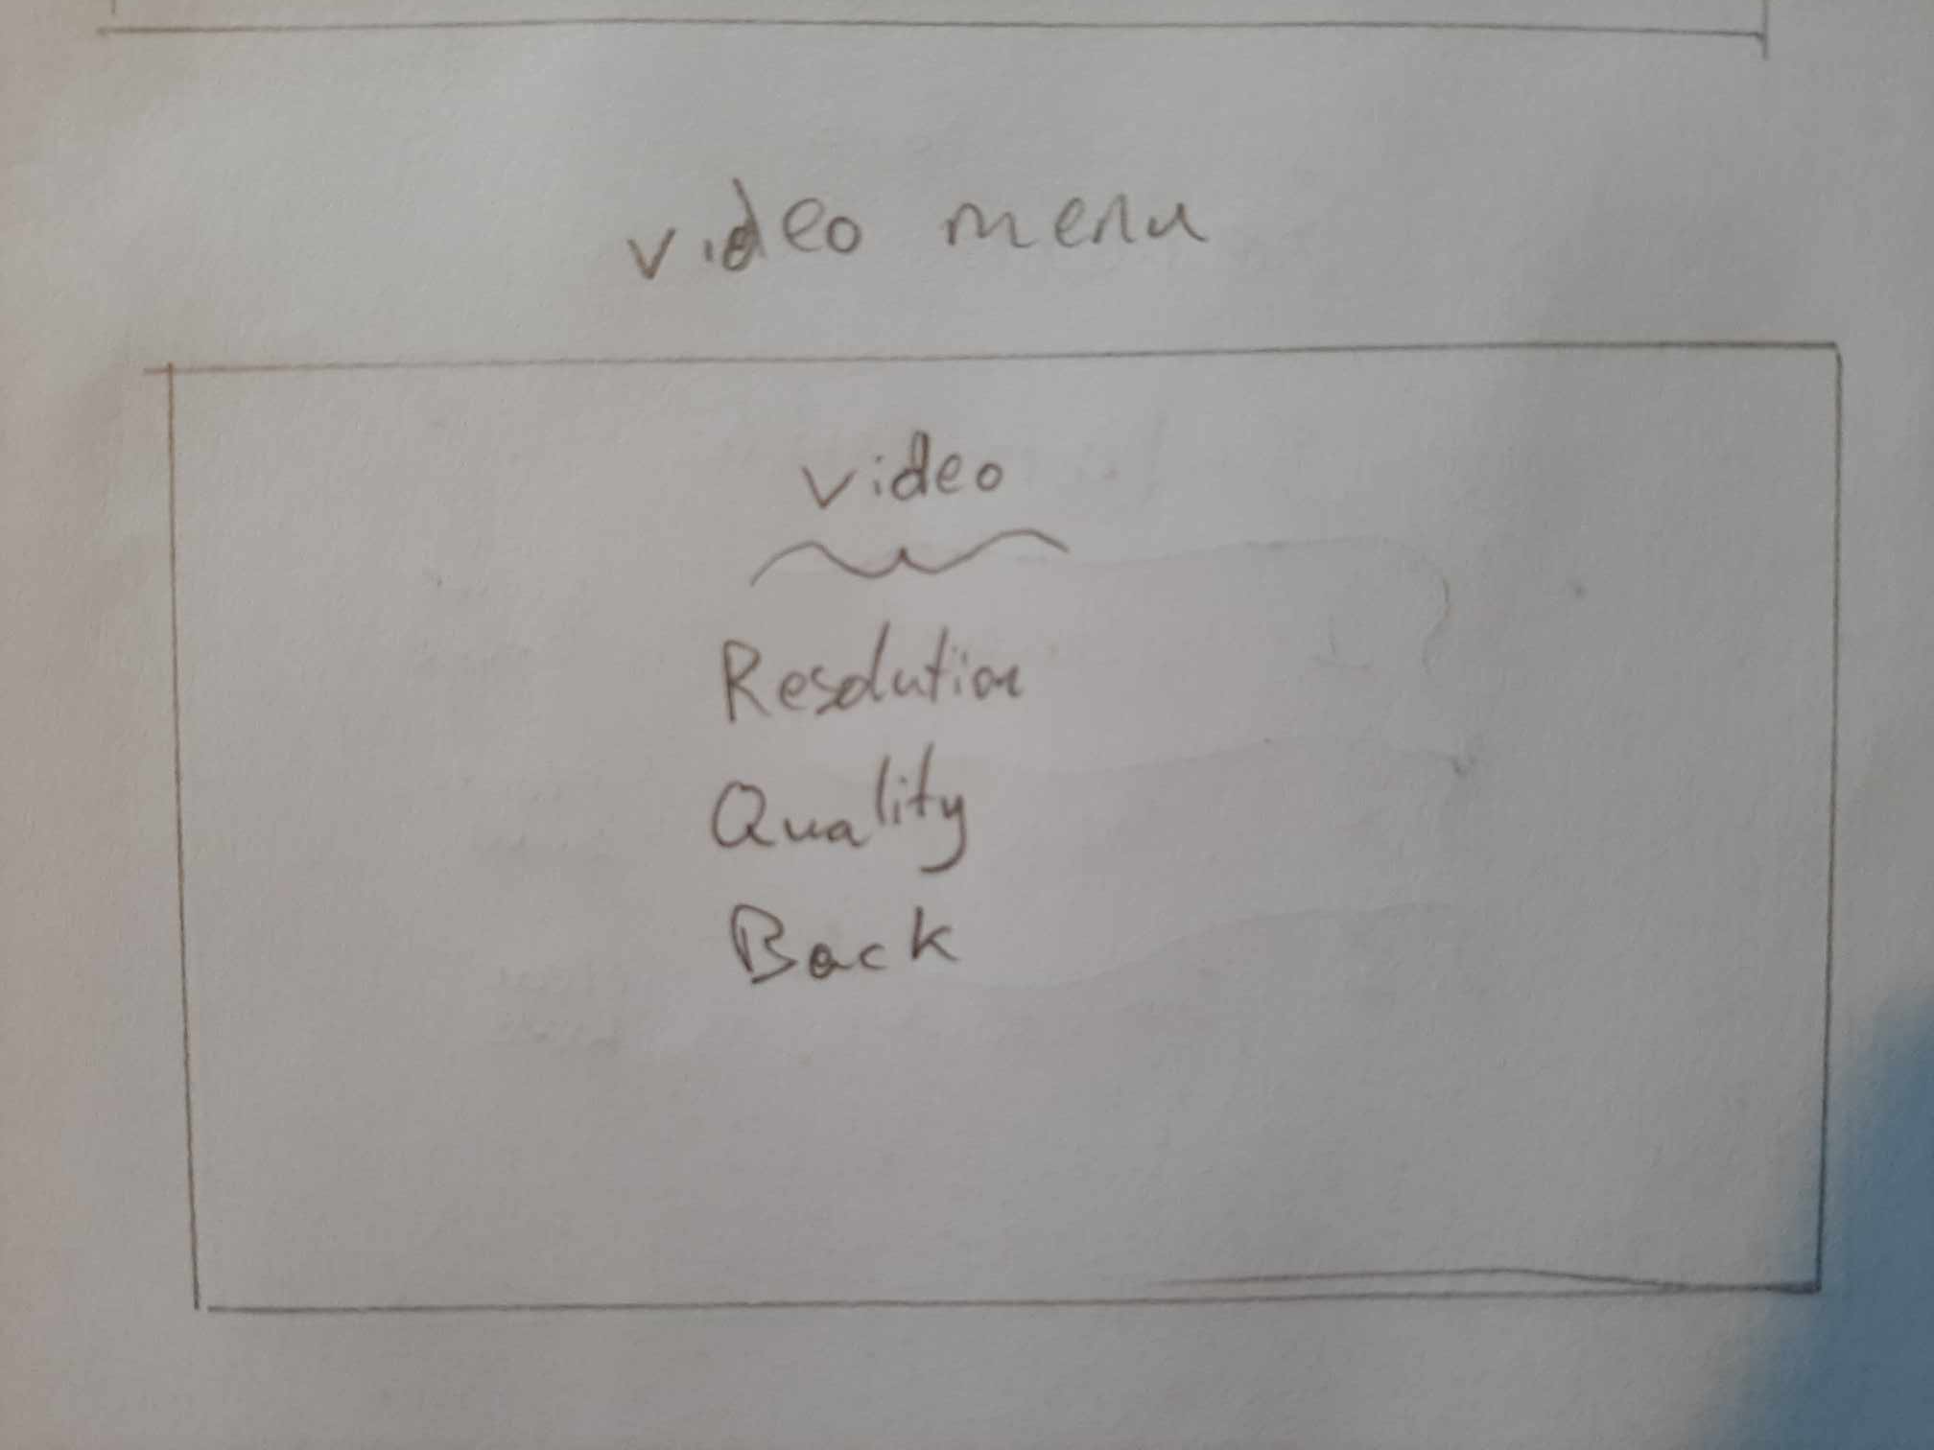

Figure 6 Video Menu sketch

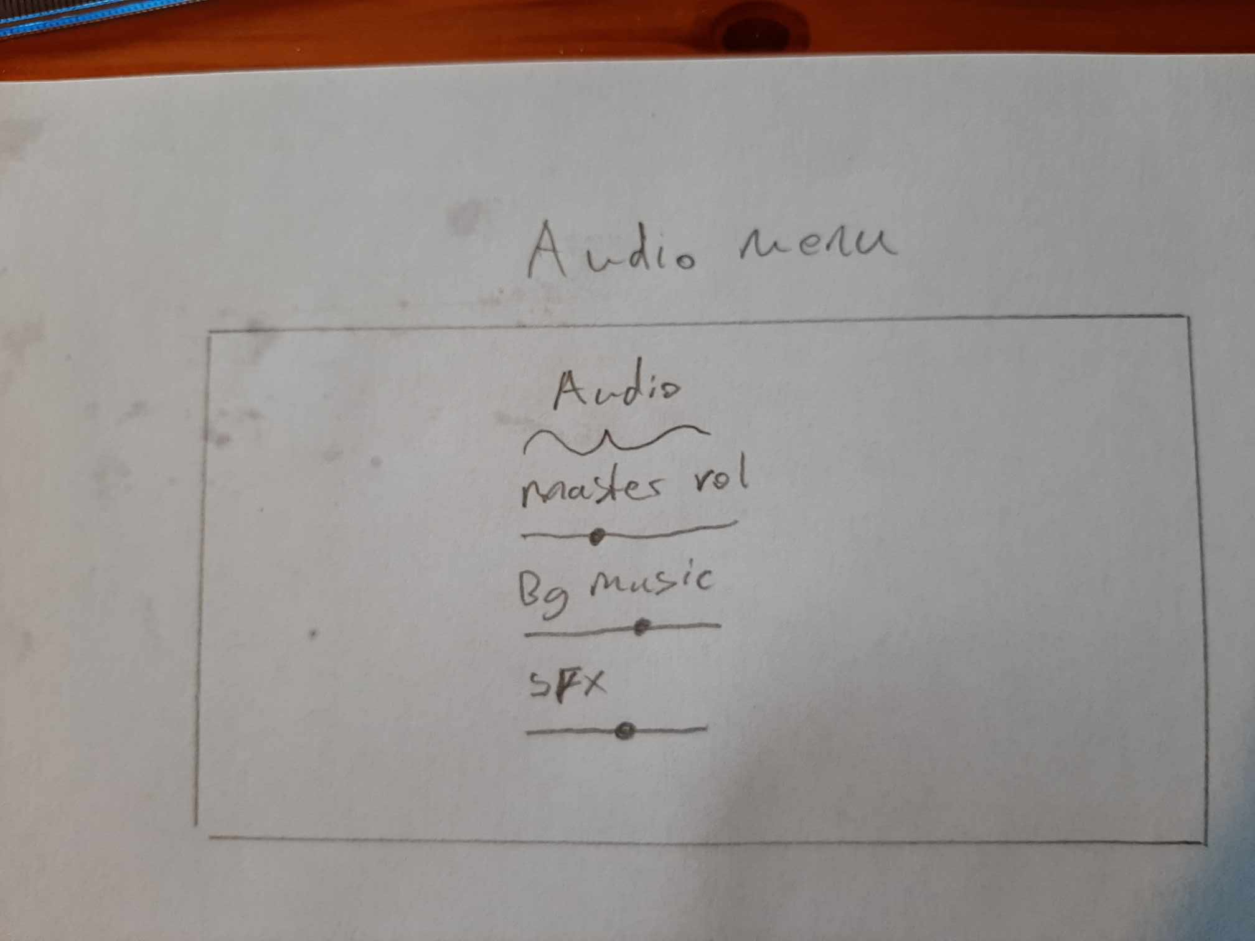

Figure 7 Audio Menu sketch

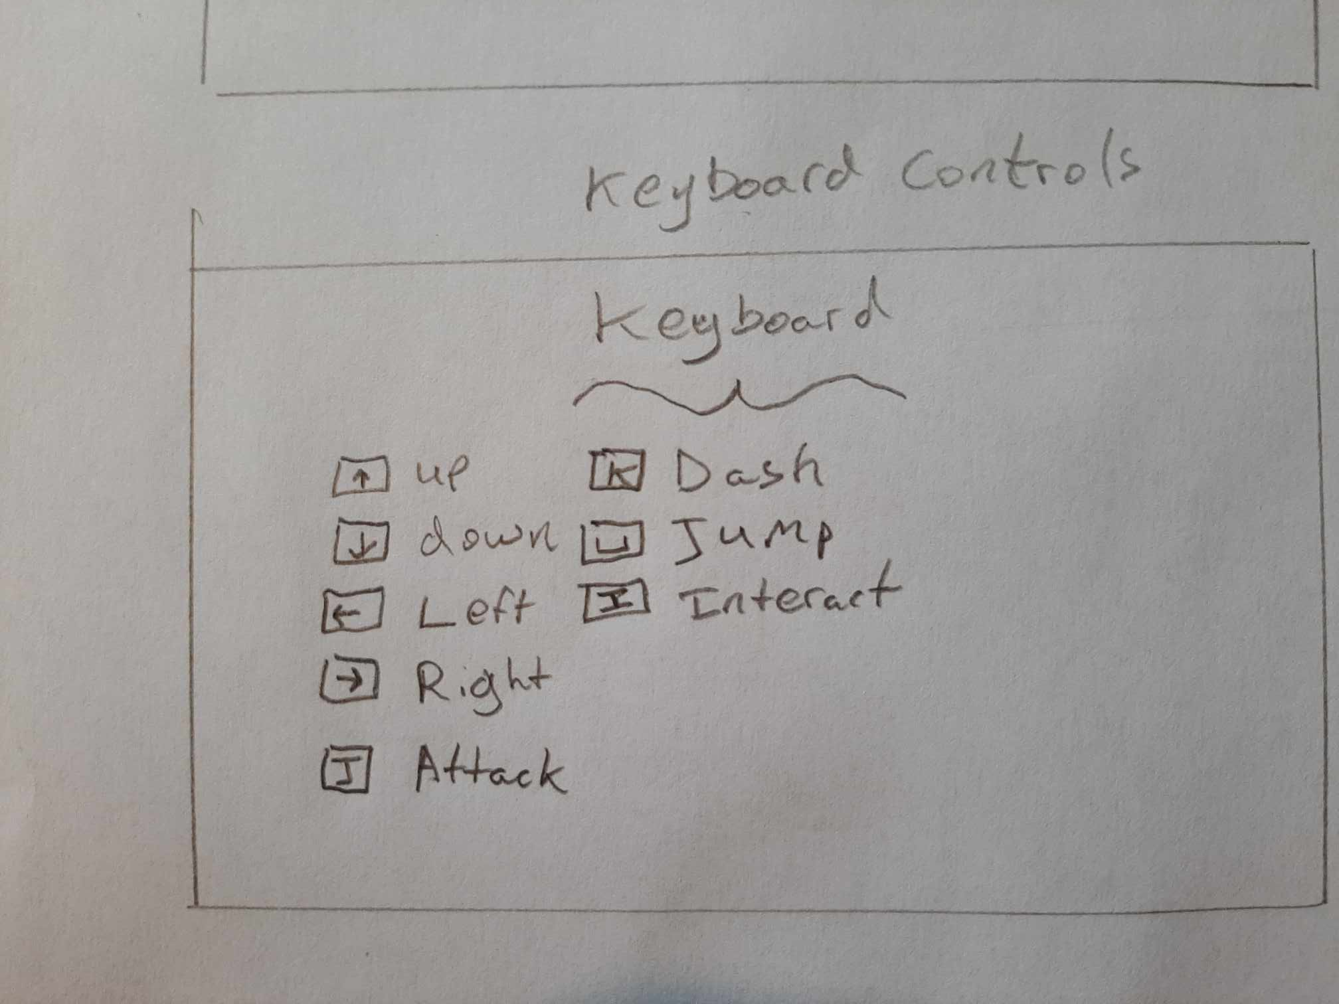

Figure 8 Keyboard Menu sketch

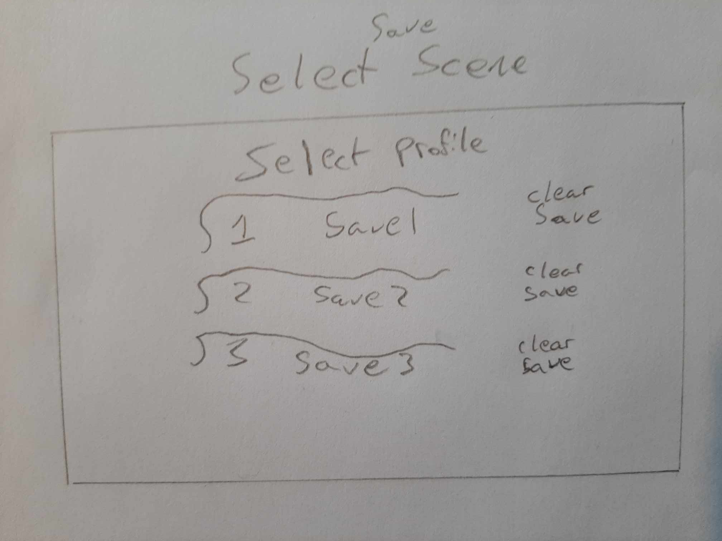

Figure 9 Select Save Menu sketch.

**Figures 10 – 15** show the author’s developed versions of the menus.

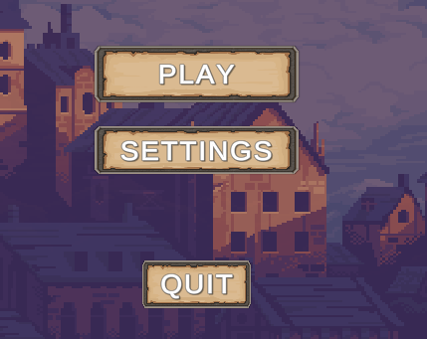

Figure 10 Main Menu

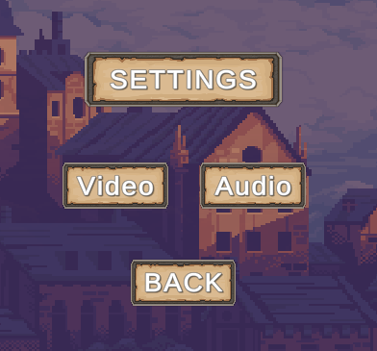

Figure 11 Settings Menu

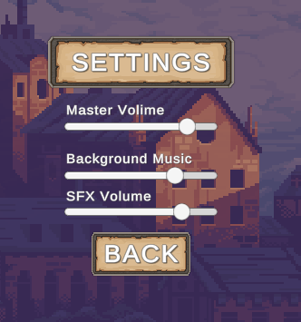

Figure 12 Settings Menu Audio

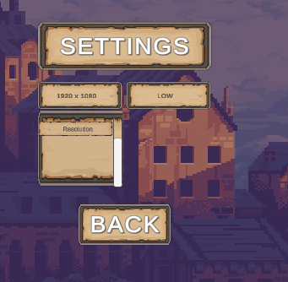

Figure 13 Settings Menu Video

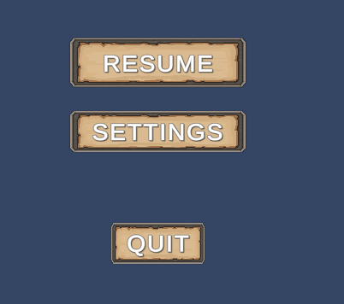

Figure 14 Pause Menu

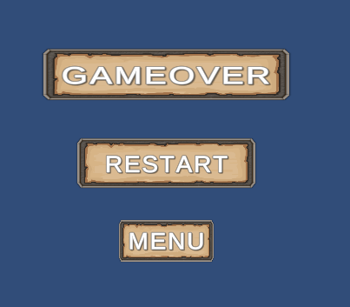

Figure 15 Death Menu

### 4.2.1 Inspiration

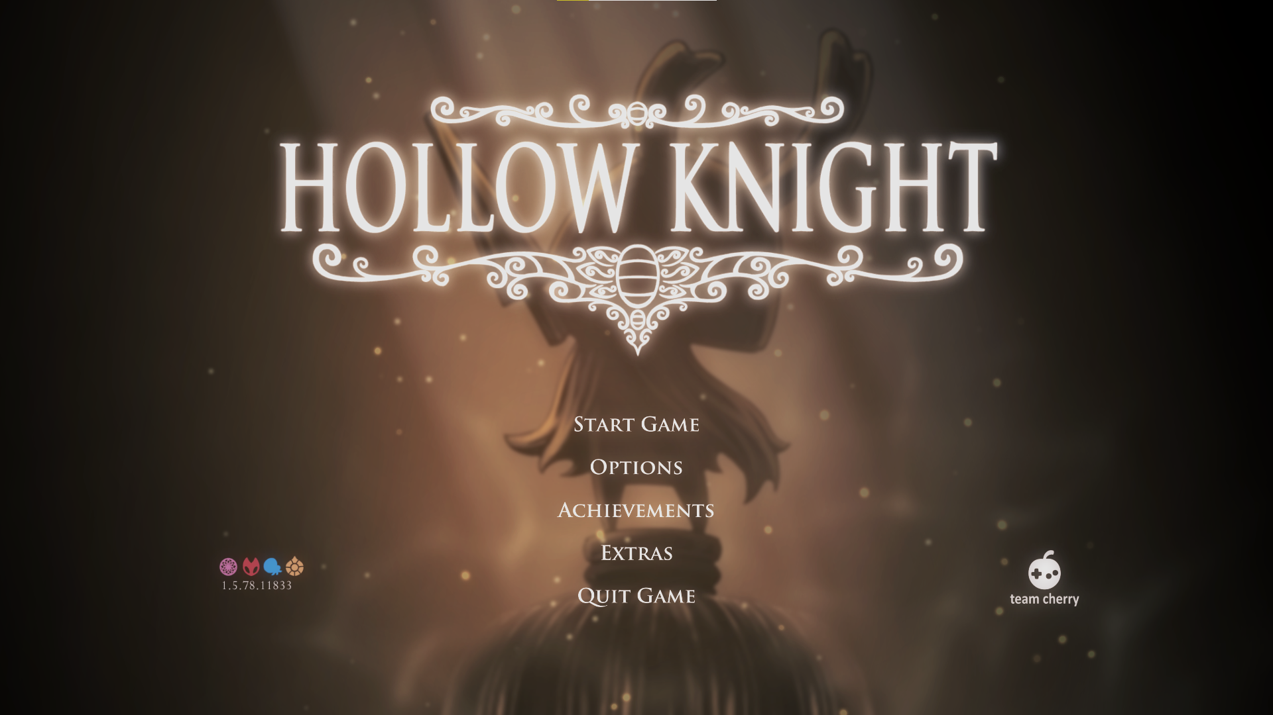

Figure 16: Screenshot taken by the author showing the Menu UI

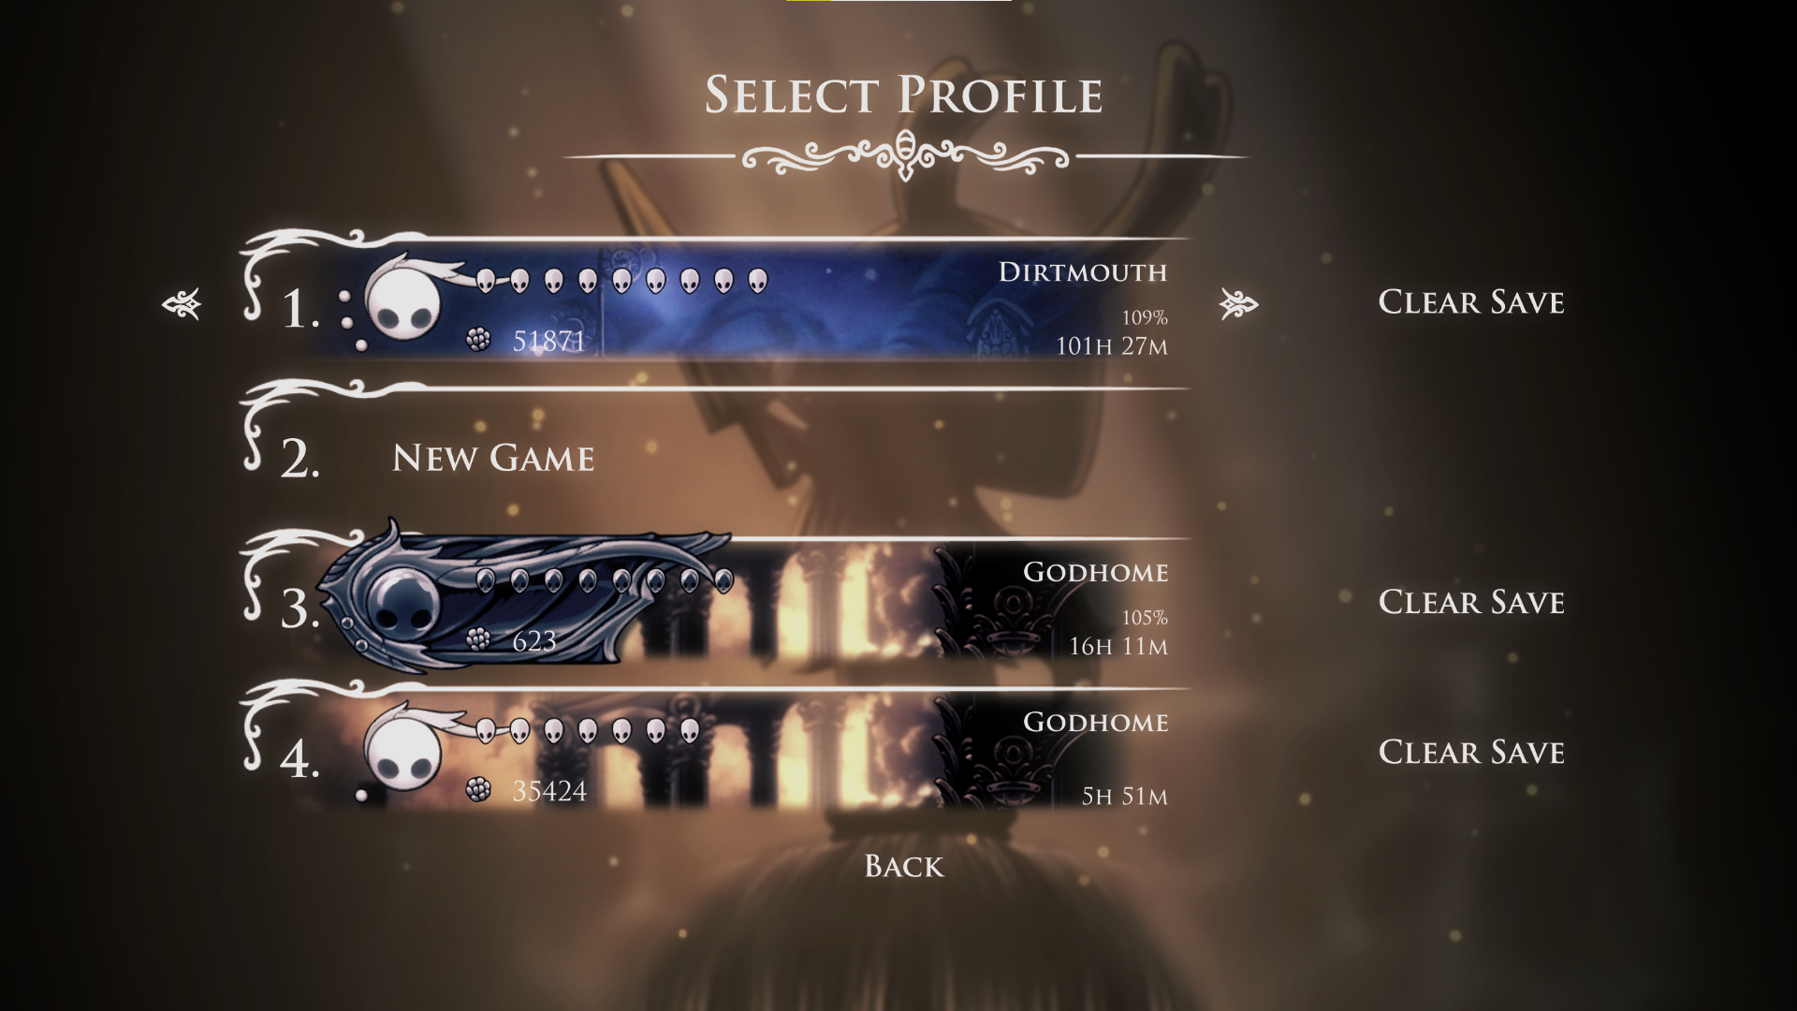

Figure 17: Screenshot taken by the author showing the save files

In **Figure 18** we can see that there are different layers to even a 2D game, this adds depth to a game where you can only move up down left and right as seen in **Figure 18** The background labelled **A** is the furthest back and will appear behind all other objects in the game. While the background labelled **B** is on top of **A** and will appear on top of that, the area labelled **C** is the plane that the player is on and can explore. The layer Labelled **D** is in front of the player Level and the player will be hidden behind objects that are on this layer. There is also a layer in front of **D** that is used occasionally.

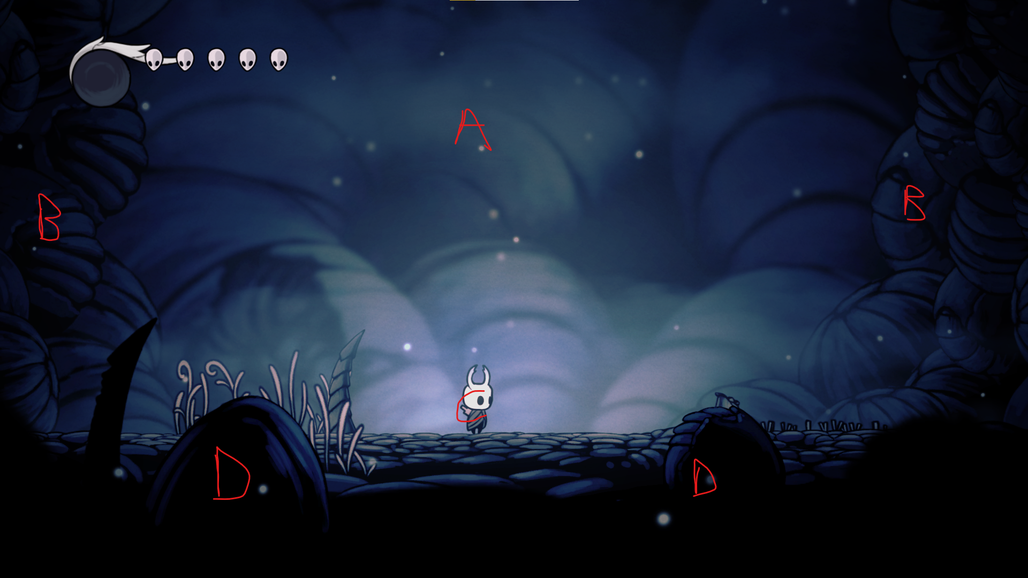

Figure 18: Screenshot taken by the author showing an example of how layers are used in Hollow Knight

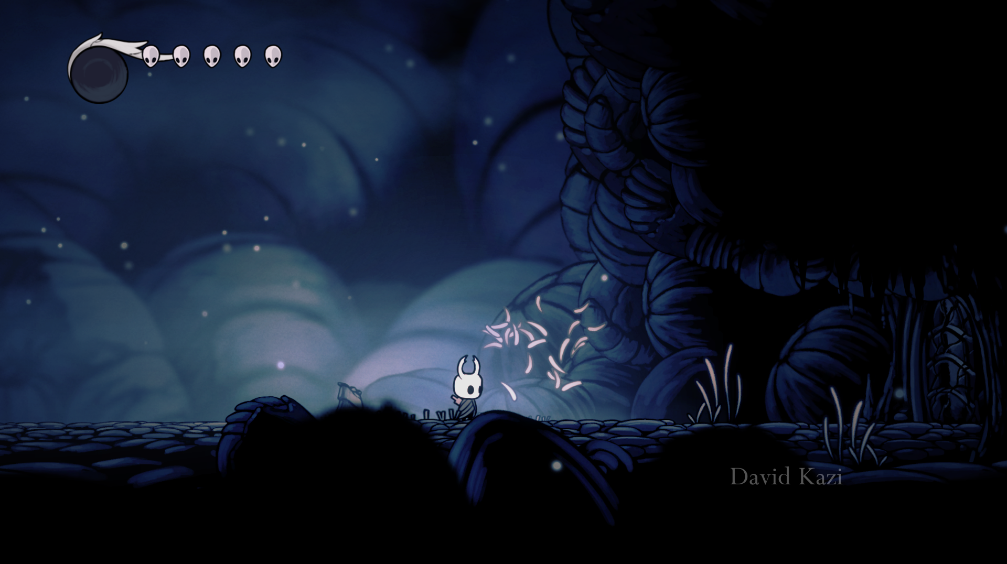 Figure 19: Showing interactable environment from Hollow Knight

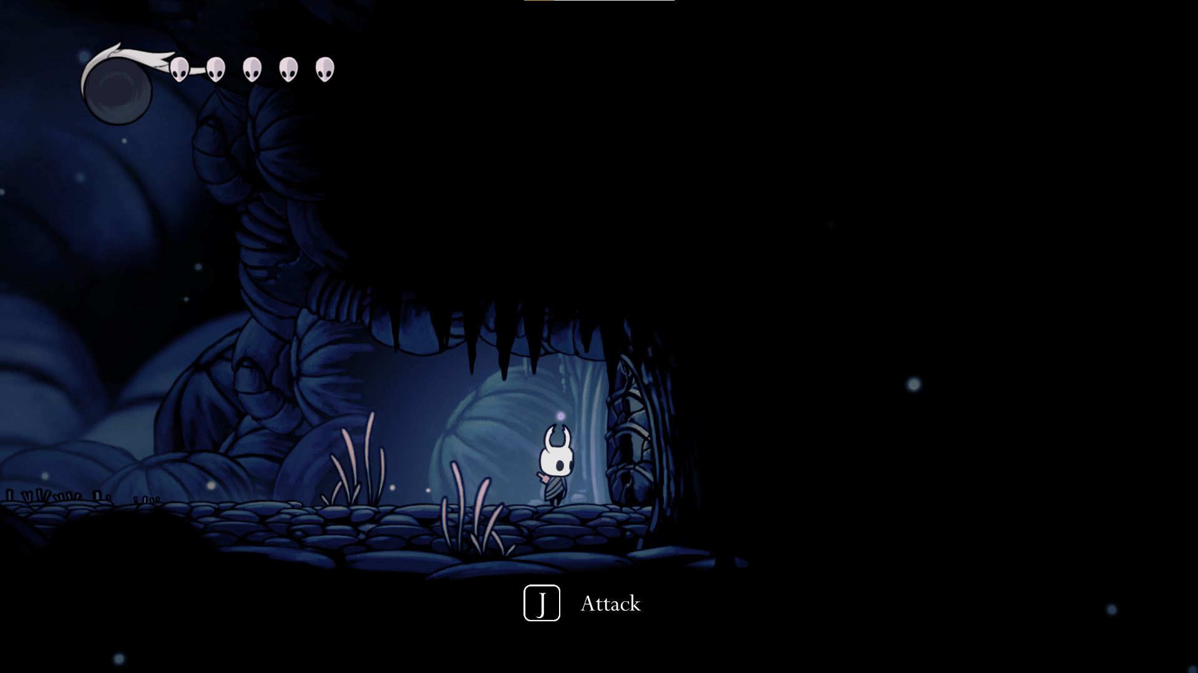

Figure 20: Showing interactable environment from Hollow Knight

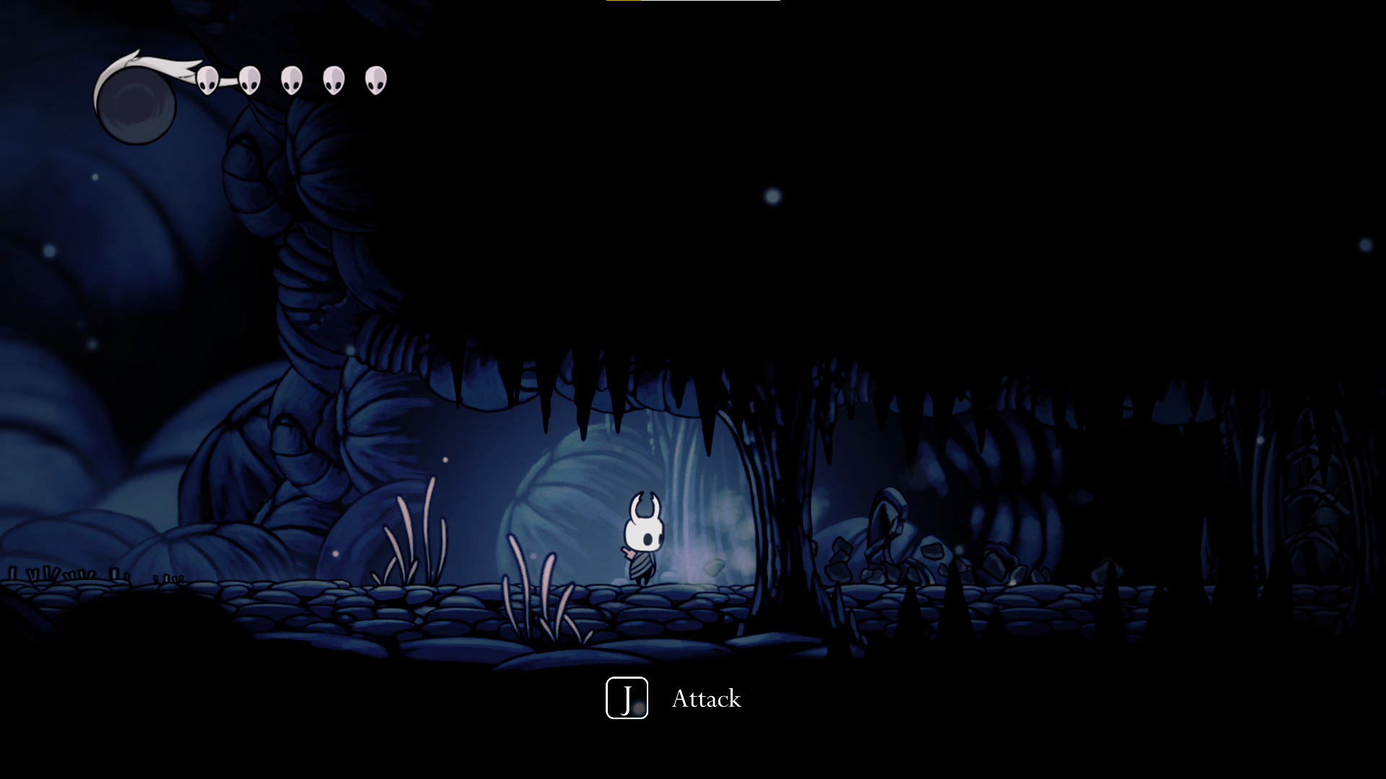

Figure 21: Showing interactable environment from Hollow Knight

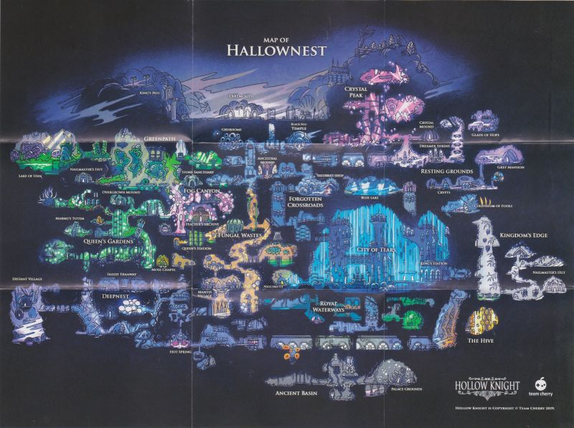

Figure 22: Full map of every area in Hollow Knight

## 4.3 Proposed Map Layout

## 4.3.1 The Crystal Village 1

In **Figures 23 – 24** the developed versions of The Crystal Village 1 are shown.

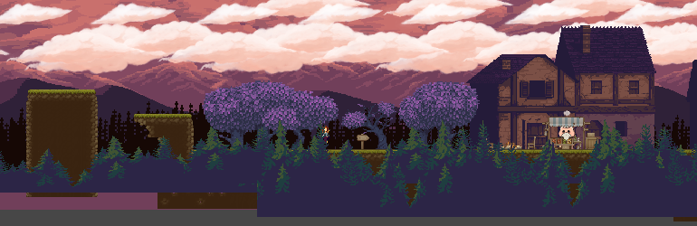

Figure 23 The Crystal Village 1

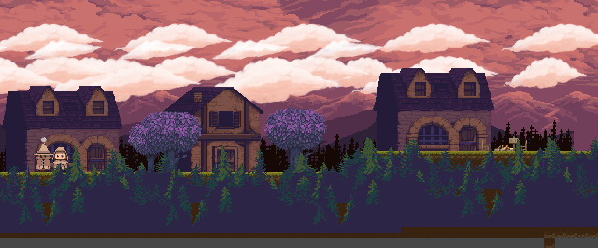

Figure 24 The Crystal Village 1

## 4.3.2 The Crystal Village 2

In **Figures 25 – 26** the developed versions of The Crystal Village 2 are shown.

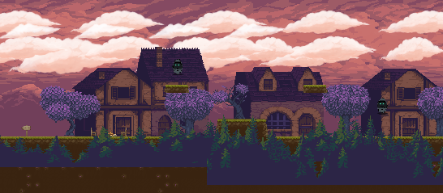

Figure 25 The Crystal Village 2

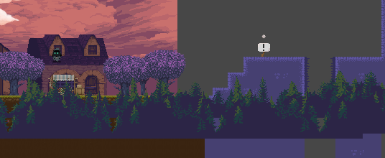

Figure 26 The Crystal Village 2

## 4.3.3 The Crystal Mines

The **Figures 27 – 29** show the developed versions of the map.



Figure 27 Section 1 of The Crystal Mines



Figure 28 Section 2 of The Crystal Mines



Figure 29 Section 3 of The Crystal Mines

The **Figures 30 – 33** show the developed versions of the map.

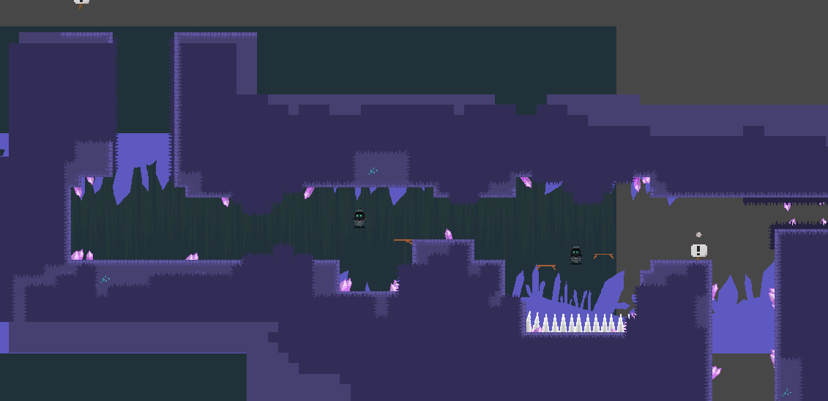

Figure 30 Crystal Mines Section 1

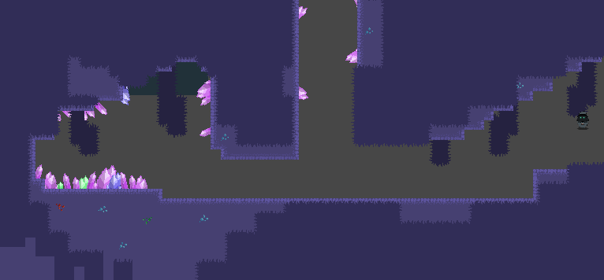

Figure 31 Crystal Mines Section 2

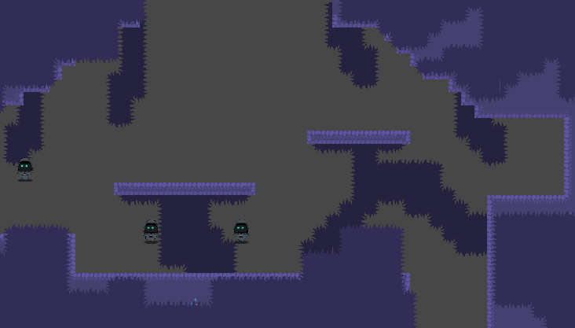

Figure 32 Crystal Mines Section 3

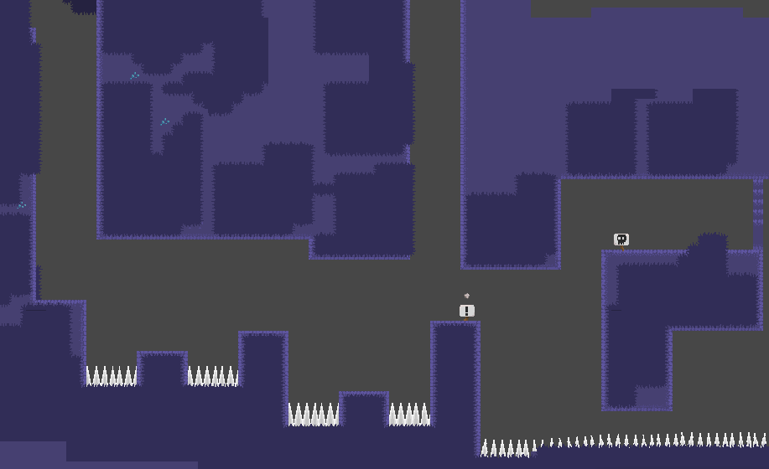

Figure 33 Crystal Mines Section 4

## 4.3.4 The Crystal Mines Boss

The **Figure 34** shows the developed map of the crystal mine boss room.

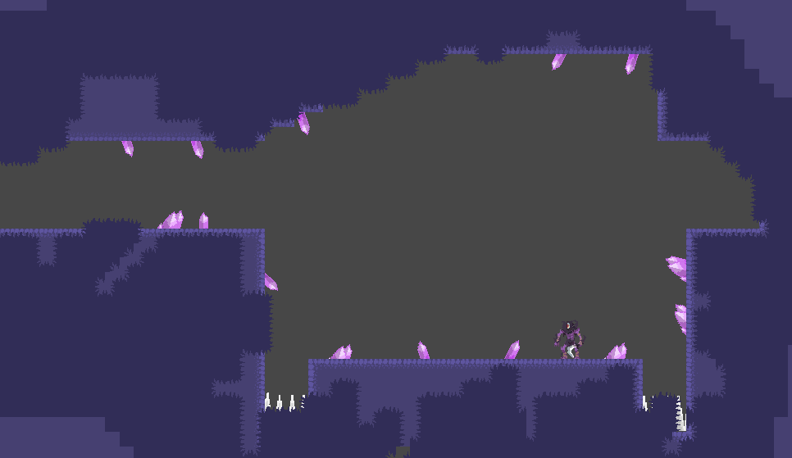

Figure 34 Crystal Mines Boss